# ArrayQueue 2

Looking at the Queue below; Follow the code executions and write in the current state of the Array at Each state.

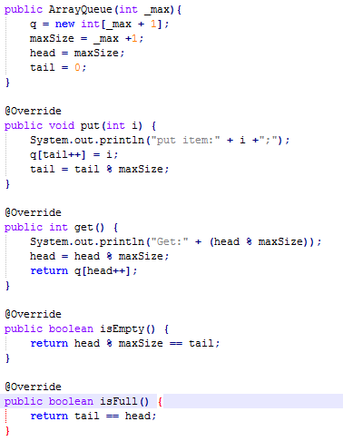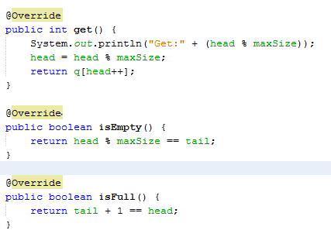

|  |  |  |  |  |  |  |  |  |  |  |  |  |  |
| --- | --- | --- | --- | --- | --- | --- | --- | --- | --- | --- | --- | --- | --- |
| **State** | **Code** |  | **Tail** | | | **T** | | **Head** | | | **H** | |  |
|  |  |  |  | | |  | |  | | |  | |  |
|  | ArrayQueue q = new ArrayQueue(10) |  |  |  | T |  |  |  |  |  |  |  | H |
|  | Put(18) | **A** | 18 | 12 |  |  |  |  |  |  |  |  |  |
| **A** | Put(12) |  | isEmpty() | | | False | | isFull() | | | False | |  |
|  |  |  |  | | |  | |  | | |  | |  |
|  | Put(44) |  | H |  |  |  |  | T |  |  |  |  |  |
|  | Put(2) | **B** | 18 | 12 | 44 | 2 | 20 |  |  |  |  |  |  |
| **B** | Put(20) |  | isEmpty() | | |  | | isFull() | | |  | |  |
|  |  |  |  | | |  | |  | | |  | |  |
|  | Get() |  |  |  | H |  |  |  | T |  |  |  |  |
|  | Get() | **C** | 18 | 12 | 44 | 2 | 20 | 18 |  |  |  |  |  |
| **C** | Put(18) |  | isEmpty() | | | False | | isFull() | | | False | |  |
|  |  |  |  | | |  | |  | | |  | |  |
|  | Put(41) |  |  |  |  | H |  |  |  |  | T |  |  |
|  | Put(34) | **D** | 18 | 12 | 44 | 2 | 20 | 18 | 41 | 34 |  |  |  |
| **D** | Get() |  | isEmpty() | | | False | | isFull() | | | False | |  |
|  |  |  |  | | |  | |  | | |  | |  |
|  | Get() |  |  |  |  |  |  | H |  |  |  | T |  |
|  | Get() | **E** | 18 | 12 | 44 | 2 | 20 | 18 | 41 | 34 | 10 |  |  |
| **E** | Put(10) |  | isEmpty() | | | False | | isFull() | | | False | |  |
|  |  |  |  | | |  | |  | | |  | |  |

|  |  |  |  |  |  |  |  |  |  |  |  |  |  |  |  |  |  |
| --- | --- | --- | --- | --- | --- | --- | --- | --- | --- | --- | --- | --- | --- | --- | --- | --- | --- |
|  | Get() |  | | T | |  | |  | |  |  |  | H |  |  |  |  |
|  | Put(33) | **F** | | 21 | | 12 | | 44 | | 2 | 20 | 18 | 41 | 34 | 10 | 33 | 21 |
| **F** | Put(21) |  | | isEmpty() | | | | | | False | | isFull() | | | False | |  |
|  |  |  | |  | | | | | |  | |  | | |  | |  |
|  | Put(90) |  | |  | |  | | T | |  |  |  |  | H |  |  |  |
|  | Put(3) | **G** | | 90 | | 3 | | 44 | | 2 | 20 | 18 | 41 | 34 | 10 | 33 | 21 |
| **G** | Get() |  | | isEmpty() | | | | | | False | | isFull() | | | False | |  |
|  |  |  | |  | | | | | |  | |  | | |  | |  |
|  | Get() | |  | |  | |  | | T |  |  |  |  |  |  |  | H |
|  | Get() | | **H** | | 90 | | 3 | | 44 | 2 | 20 | 18 | 41 | 34 | 10 | 33 | 21 |
| **H** | Get() | |  | | isEmpty() | | | | | False | | isFull() | | | False | |  |
|  |  | |  | |  | | | | |  | |  | | |  | |  |
|  | Get() | |  | |  | | H | | T |  |  |  |  |  |  |  |  |
|  | Get() | | **I** | | 90 | | 3 | | 44 | 2 | 20 | 18 | 41 | 34 | 10 | 33 | 21 |
| **I** | Get() | |  | | isEmpty() | | | | | False | | isFull() | | | True | |  |
|  |  | |  | |  | | | | |  | |  | | |  | |  |
|  | Put(82) | |  | |  | | H | | T |  |  |  |  |  |  |  |  |
|  | Put(15) | | **J** | | 90 | | 82 | | 15 | 2 | 20 | 18 | 41 | 34 | 10 | 33 | 21 |
| **J** | **Final State** | |  | | isEmpty() | | | | | False | | isFull() | | | False | |  |